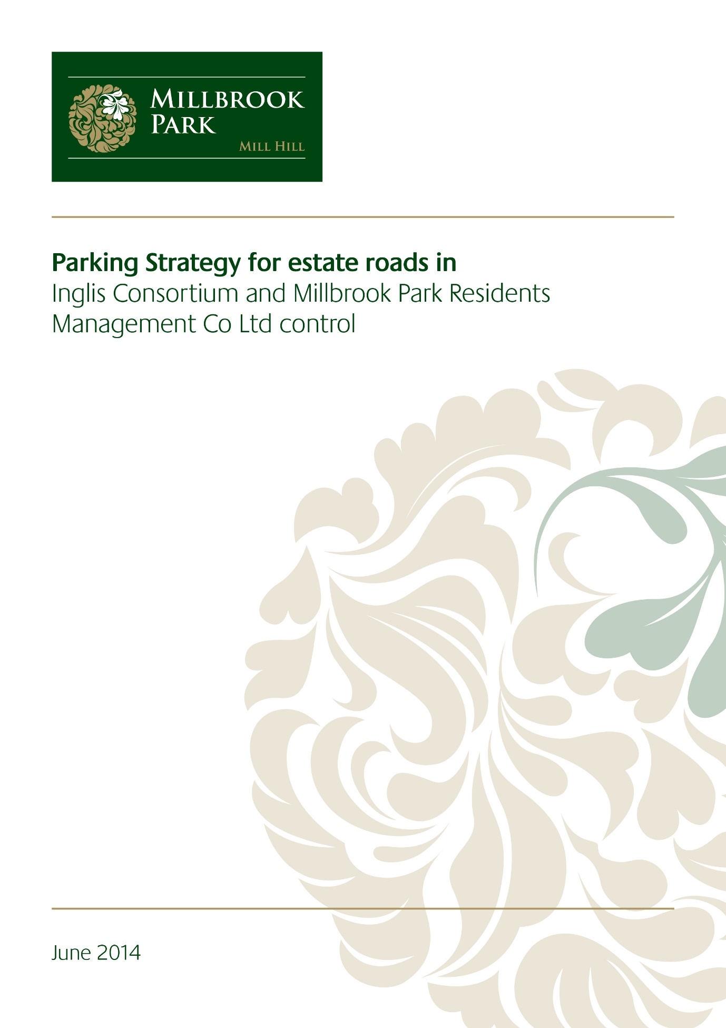
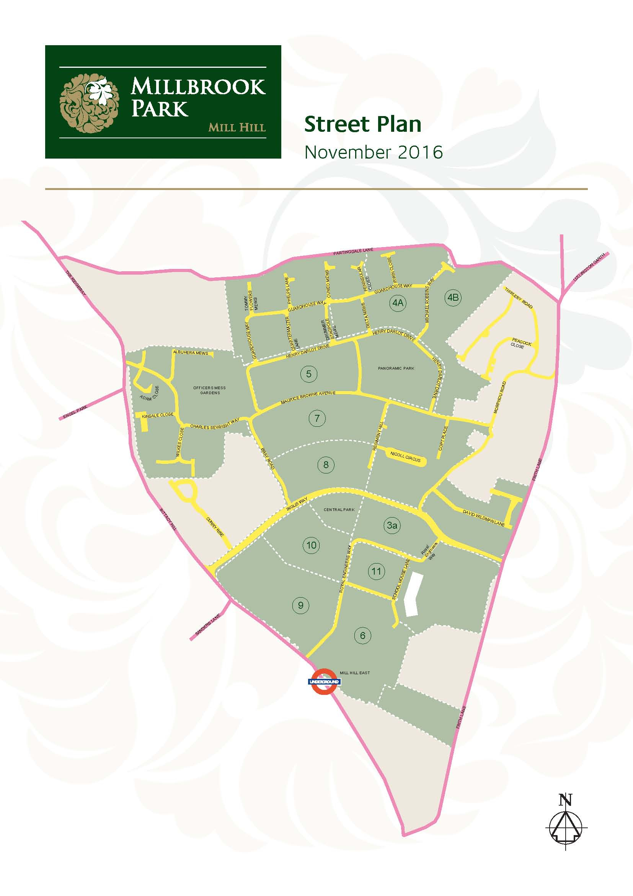

December 2020.

General Information

Management Company Role
Millbrook Park Residents Management Company Ltd (MPRMC) has been set up to manage the maintenance and replacement of parks, landscaped areas and private (non-adopted) roads within Millbrook Park
Each occupier of properties within Millbrook Park contributes regularly to the cost of this service, via the estate service charge.

Managing Agents
The Millbrook Park Residents Management Co. Ltd (The Estate Management Company) have appointed Mainstay Residential Ltd to act as managing agents for Millbrook Park
Mainstay employ a dedicated named Property Manager to interact with all freehold owners and leaseholders who are members of MPRMC. When you completed your purchase you will have been provided with all salient contact and other detail, but if you require additional information please contact Mainstay's London office on 0207-099-5000 or contact Mainstays Estate Manager, Matt Knight, who is onsite each working day and can be contacted on 07734 366 337.

Speed limits
Inglis Way has 30mph limit. All other roads within Millbrook Park have a maximum 20mph speed restriction.
Signage is erected in certain areas to confirm the above. All residents are asked to respect these speed restrictions.

Adopted Highways
Only 1 road within Millbrook Park will be adopted by London Borough of Barnet. This means that after adoption the responsibility for maintenance and management will transfer to the authority.
This road is Inglis Way, and it is thought that the adoption will be completed by 2025 at the earliest.
Until that time Inglis Way will remain in the ownership of the Inglis Consortium LLP.
Royal Engineers Way will not be adopted by London Borough of Barnet and will remain in the ownership and control of the Management Company in perpetuity.

Privately maintained roads.
The majority of roads within Millbrook Park will be privately managed by Millbrook Park Residents Management Company Ltd (MPRMC) and their appointed managing agent Mainstay Residential.
As roads are completed and handed over to MPRMC they will be placed into management. Normal practice is that the roads within the development phases will be retained by the Developer until all sales of dwellings within that phase are completed and occupied.

Bus Services
Bus services 221, 240 and 382 serve the site as of November 2016.

Parking Restrictions.
The following streets have parking restrictions in place.

Inglis Way
Parking is prohibited at all times and double yellow lines have been inserted to the roadways to indicate such with signage erected outlining the conditions covering parking.
No visitor permit parking will be allowed, other than in the 6 x spaces clearly marked for such use in the vicinity of Central Park, or the 10 x spaces marked VDO in the same area.
Contractor’s permits may be issued by the Parking Management Company (PCM) for limited periods only.
It is expected that this road will be adopted by London Borough Barnet in 2025 at the earliest at which time all maintenance and parking controls will pass to them.

Royal Engineers Way (includes Bus Turnaround Layby)
Royal Engineers Way will not now be adopted by London Borough of Barnet but will be a private road owned and controlled by Inglis Consortium or Millbrook Park Residents Management Co Ltd.
Parking is prohibited at all times, except in a defined area during school drop/collect times, with signage erected to outline the conditions in force.
This road acts as a bus turnaround and boarding facility for the 382 service.
No visitor permit parking will be allowed.
Contractor’s permits may be issued by PCM for limited periods only.

School House Lane
This road provides the only vehicular access at present to Millbrook Park C of E Primary School.
Parking is prohibited at all times, except in a defined area during school drop/collect times, with signage erected to outline the conditions in force.

No permits will be issued.

Morphou Road
The first section of road up to no. 87 Morphou Road is in Management Company ownership. The remainder of this road to the north through Ridgemont is in other ownership and subject to different rules.
Parking is prohibited at all times and double yellow lines have been inserted to the roadways to indicate such with signage erected outlining the conditions covering parking.
No occupier or visitor permits will be issued.

Bray Road
Parking in this road is restricted to Notting Hill Housing resident permit holders only, with the exception of 4 x visitor spaces for which visitor permits (obtainable from the parking enforcement agency) are required.

Curry Rise
This is private road outside of the Millbrook Park Residents Management Company ownership and parking is restricted by the owners to occupiers only.

Charles Sevright Way.
This road leads into Millbrook Park from the Ridgeway.
Parking is prohibited at all times and double yellow lines have been inserted to the roadways to indicate such with signage erected outlining the conditions covering parking.
No occupier or visitor permits will be issued.
Contractor’s permits may be issued by PCM for limited periods only

Henry Darlot Drive
The first section of this road is open.
Parking Restrictions will apply.
The parking restrictions will be displayed by signage erected on lamp posts.
No occupier or visitor permits will be issued.
Contractor’s permits may be issued by PCM for limited periods only.

Maurice Brown Avenue
This road leads from Morphou Road in the east to join Charles Sevright Way in the west. The first section opened for occupiers in 2017, and links to Regiment Hill and Nicholl Circus. The first 100 metres of Maurice Brown Avenue (From the turning off Morphou Rd up to the junction with Copt Place) are not in the ownership of The Millbrook Park Residents Management Company and are controlled by others.
Parking Restrictions will apply.
The parking restrictions will be displayed by signage erected on lamp posts.
No occupier or visitor permits will be issued.
Contractor’s permits may be issued by PCM for limited periods only.

Regiment Hill
Parking Restrictions will apply.
The parking restrictions will be displayed by signage erected on lamp posts.
No occupier or visitor permits will be issued.
Contractor’s permits may be issued by PCM for limited periods only.

Guardhouse Way
Parking Restrictions will apply.
The parking restrictions will be displayed by signage erected on lamp posts.
No occupier or visitor permits will be issued.
Contractor’s permits may be issued by PCM for limited periods only.

